Want to share our posts?
Iowa Immunizes: Twitter (@iowaimmunizes), Facebook (welcome page), Instagram (@iowaimmunizes)
Iowa Public Health Association: Twitter (@IowaPHA)

University of Iowa Prevention Research Center for Rural Health: Twitter (@UIowaPRCRH)

Want to create your own?

Social Media Images

(Choose either image)
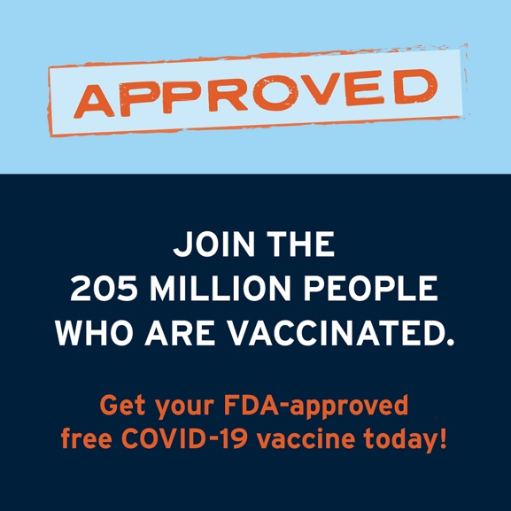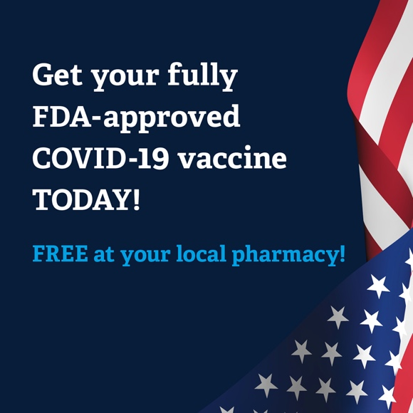

Sample Message (FB/Instagram/Twitter)
After reviewing even more safety data, the FDA has given the Pfizer COVID-19 vaccine full approval – its ultimate vote of confidence. Join the millions who have already gotten a safe, effective, and free COVID-19 vaccine.

Email Blurb

Hello!

The University of Iowa Prevention Research Center for Rural Health, Iowa Public Health Association, and Iowa Immunizes have developed a campaign in response to the FDA approval of the Pfizer (Comirnaty) vaccine.

The campaign was developed by a team that specializes in health communication for behavior change, and it was informed by conversations with multiple organizations about barriers to COVID-19 vaccination in their community. The messages and images were also tested with a Virtual Review Panel that includes members from rural Iowa communities.

Please distribute this campaign widely! We are attaching file sizes that are suitable for digital ads so that you can post this on social media and share with your partners and listservs.

Thank you for your help getting more Iowans protected against COVID-19.

Newsletter Blurb
(Choose either image)

The Pfizer, Moderna and J&J vaccines have been authorized under an Emergency Use Authorization (EUA). Now the Pfizer (Comirnaty) vaccine has been through a review and full approval. What does this mean?
- For full approval of a new drug, the FDA requires extensive data on safety and effectiveness, inspection of manufacturing facilities, and a comprehensive review of all clinical and “real world” use.
- Both the Emergency Use Authorization (EUA) and approval ensure that the COVID-19 vaccine is safe and can be used to protect against COVID-19.
- If you were waiting for FDA approval, now is the time to head to your local pharmacy and protect yourself and your loved ones from COVID-19

