Want to share our posts?
Iowa Immunizes: Twitter (@iowaimmunizes), Facebook (welcome page), Instagram (@iowaimmunizes)
Iowa Public Health Association: Twitter (@IowaPHA)

University of Iowa Prevention Research Center for Rural Health: Twitter (@UIowaPRCRH)

Want to create your own?

Social Media Images

(Choose either image)
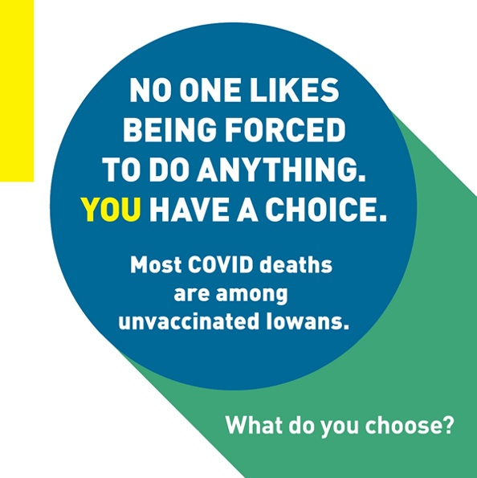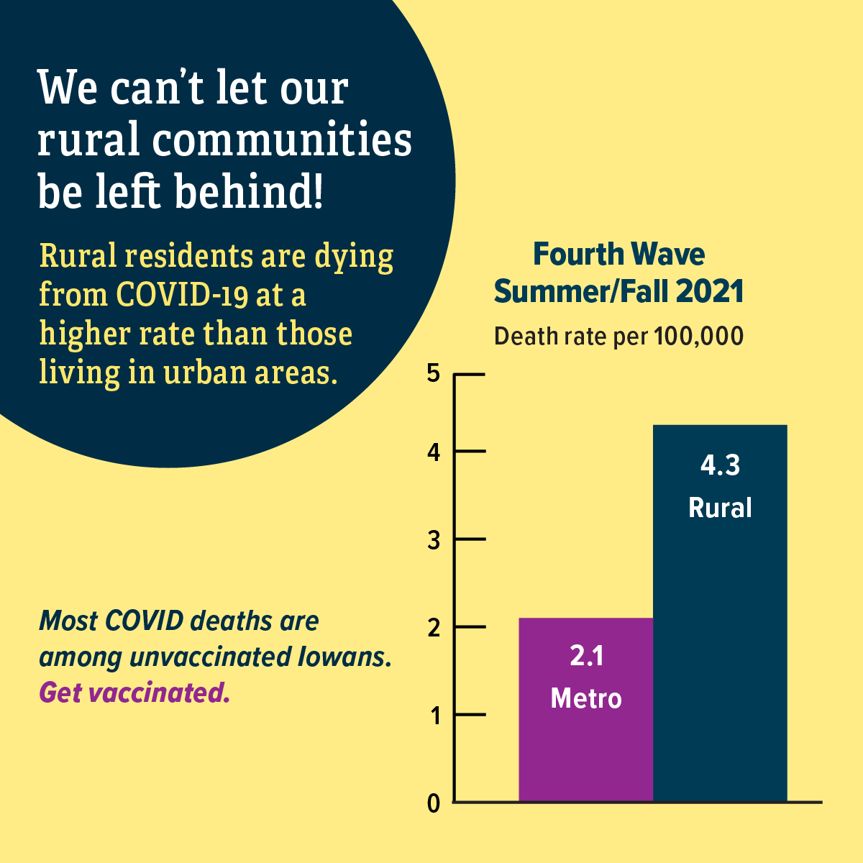

Sample Message (Facebook/Instagram/Twitter)

Data suggests that the Omicron variant is more contagious than other variants, including the fast-spreading Delta variant in Summer/Fall of 2021. Any coronavirus infection can be life-threatening, and the best way to prevent the spread of this or any other variant is to get vaccinated.

Email Blurb

Hello!

The University of Iowa Prevention Research Center for Rural Health, Iowa Public Health Association, and Iowa Immunizes have developed a campaign in response to the multiple COVID variants emerging in Spring of 2022.

Variants emerge as a result of naturally occurring mutations in viruses. As long as COVID-19 spreads, mutations and new variants are expected to occur. It is important to continue messaging that the best way to prevent the spread of COVID-19 is to get vaccinated and boosted.

The campaign was developed by a team that specializes in health communication for behavior change. The messages and images were also tested with a Virtual Review Panel that includes members from rural Iowa communities.

Please distribute this campaign widely! We are attaching file sizes that are suitable for digital ads so that you can post this on social media and share with your partners and listservs.

Thank you for your help getting more Iowans protected against COVID-19.

