Want to share our posts?

University of Iowa Prevention Research Center for Rural Health: Twitter (@UIowaPRCRH)
Iowa Public Health Association: Twitter (@IowaPHA)
Iowa Immunizes: Twitter (@iowaimmunizes), Facebook (welcome page), Instagram (@iowaimmunizes)

Want to create your own?

Social Media Images

(Choose either image)
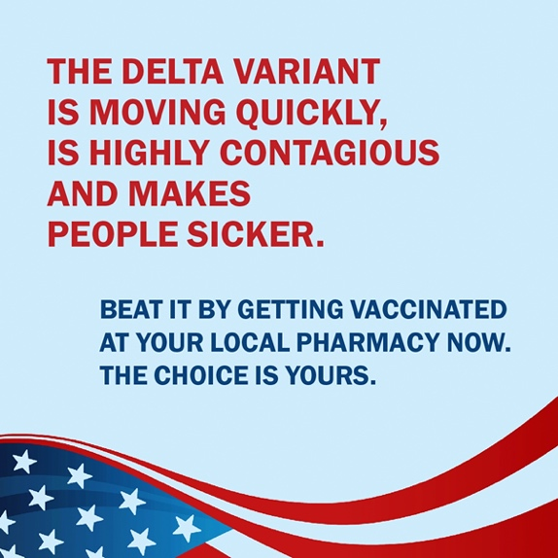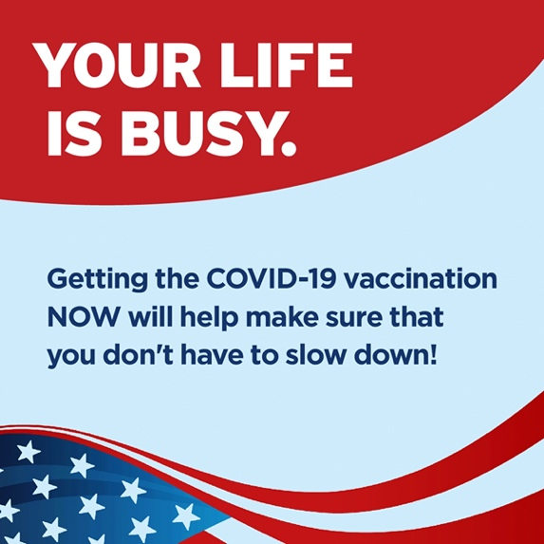

Sample Message (FB/Instagram/Twitter)
Vaccination is the most important public health action to end the COVID-19 pandemic. Stop by your local pharmacy today to get yours!

Email Blurb
(Choose either image)
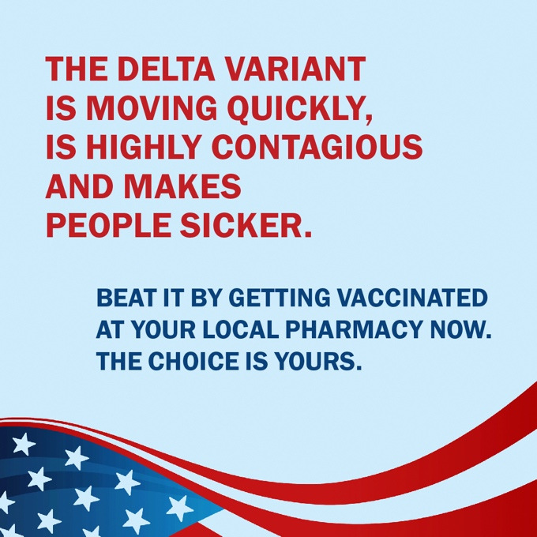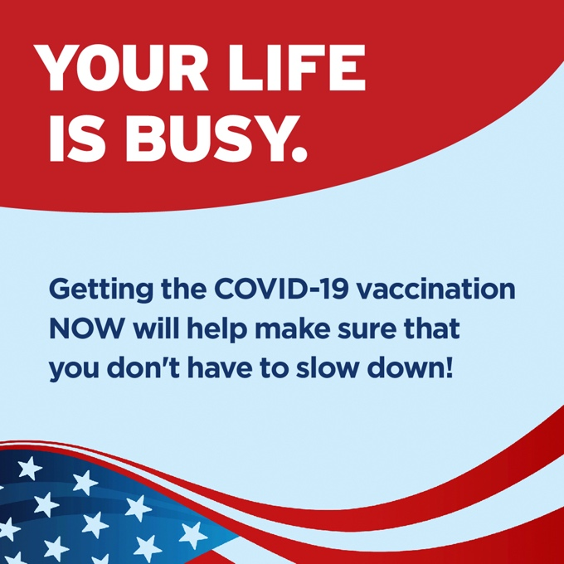

Hello!

The University of Iowa Prevention Research Center for Rural Health, Iowa Public Health Association, and Iowa Immunizes have developed a campaign in response to the COVID-19 Delta variant surge.

The campaign was developed by a team that specializes in health communication for behavior change, and it was informed by conversations with multiple organizations about COVID-19 in their community. The messages and images were also tested with a Virtual Review Panel that includes members from rural Iowa communities.

Please distribute this campaign widely! We are attaching file sizes that are suitable for digital ads so that you can post this on social media and share with your networks.

Thank you for your help getting more Iowans protected against COVID-19.

Newsletter Blurb
(Choose either image)
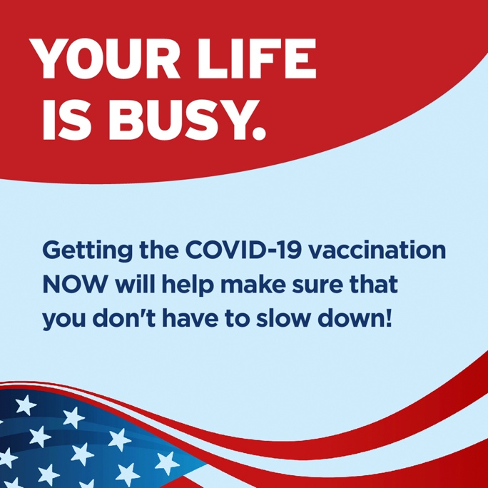

5 things you need to know about COVID-19 and Delta variant:
- Getting vaccinated prevents severe illness, hospitalizations, and death; it also helps reduce the spread of the virus in communities.
- Data show that Delta is more contagious compared with earlier strains of the virus.
- In areas with substantial and high transmission, CDC recommends that everyone (including fully vaccinated individuals) wear a mask in public indoor settings to help prevent the spread of Delta and protect others.
- CDC recommends that community leaders encourage vaccination and masking to prevent further outbreaks in areas of substantial and high transmission.
- CDC recommends universal indoor masking for all teachers, staff, students, and visitors to K-12 schools, regardless of vaccination status.
Head to your local pharmacy and protect yourself from Delta today!

